**Submitted by:**

Aryaman Srivastava 2210110206

|  |  |  |  |  |  |  |  |  |
| --- | --- | --- | --- | --- | --- | --- | --- | --- |
|  | Logn (in ns) | √n  (in ns) | n  (in ns) | Nlogn  (in ms) | n^2  (in ms) | n^2logn  (in ms) | 2^n  (in ms) | N^n  (in ms) |
| 1 | 1700 | 1000 | 600 | 0 | 0 | 0 | 0 | 0 |
| 10 | 2000 | 1100 | 700 | 0 | 0 | 1 | 0 | 84660 |
| 100 | 3100 | 1200 | 1800 | 2 | 2 | 4 | 20006 | Too big |
| 1000 | 3700 | 1600 | 7700 | 2 | 4 | 58 | Too big | Too big |
| 10000 | 4300 | 1900 | 81700 | 3 | 37 | 2062 | Too big | Too big |
| 100000 | 5800 | 2800 | 728300 | 37 | 8902 | Too big | Too big | Too big |
| 1000000 | 6600 | 3600 | 2041400 | 131 | Too big | Too big | Too big | Too big |

**Table:**

**Graphs:**

**1. Logn**

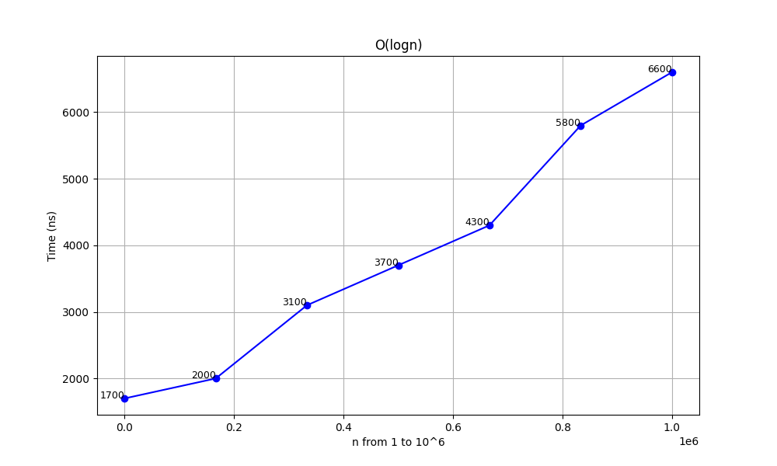

**2. √n**

**3. n**

**4. n logn**

**5. n^2**

**6. n^2 logn**

**7. 2^n**

**8. n^n**

